

**CAPSTONE PROJECT REPORT**

**Report 1 – Project Introduction**

|  |  |  |
| --- | --- | --- |
| **CMA Team** | | |
| **Project team** | Nguyen Thi Trang | SE05803 |
| Nguyen Duc Thien | SE05883 |
| Le Thi Thu Trang | SE05909 |
| Do Ngoc Khanh | SE06047 |
| Do Trung Duc | SE05844 |
| **Supervisor** | Mr. Bui Dinh Chien | |
| **Project code** | CMA | |

– Hanoi, August 2020 –

**Table of Contents**

I. Project Report **3**

1. Status Report 3

2. Team Involvements 3

3. Issues/Suggestions 3

II. Project Introduction **4**

1. Overview 4

1.1 Project Information 4

1.2 Project Team 4

a. Supervisor 4

b. Team Members 4

2. Product Background 4

3. Existing Systems 4

3.1 Ultrasound Clinic 5

3.2 BigSoft 6

3.3 Nano clinic 8

4. Business Opportunity 10

5. Software Product Vision 10

6. Project Scope & Limitations 10

6.1 To be 10

6.2 Major Features 11

6.3 Limitations & Exclusions 12

# I. Project Report

## 1. Status Report

|  |  |  |  |
| --- | --- | --- | --- |
| **#** | **Work Item** | **Status** | **Notes (Work Item in Details)** |
| 1 |  | Pending |  |
| 2 |  | In Progress |  |
| 3 |  | Completed |  |

## 2. Team Involvements

|  |  |  |  |
| --- | --- | --- | --- |
| **#** | **Task** | **Member** | **Notes (Task Details, etc.)** |
| 1 |  |  |  |
| 2 |  |  |  |
| 3 |  |  |  |

## 3. Issues/Suggestions

|  |  |  |  |
| --- | --- | --- | --- |
| **#** | **Issue** | **Status** | **Notes (Solution, Suggestion, etc.)** |
| 1 |  | Pending |  |
| 2 |  | In Progress |  |
| 3 |  | Completed |  |

# II. Project Introduction

## 1. Overview

### 1.1 Project Information

* Project name: Clinic Management Application
* Project code: CMA
* Group name: SWP490-G23
* Software type: Web-based application

### 1.2 Project Team

#### a. Supervisor

|  |  |  |  |
| --- | --- | --- | --- |
| **Full Name** | **Email** | **Phone Number** | **Title** |
| Bui Dinh Chien | ChienBD@fe.edu.vn |  | Lecturer |

#### b. Team Members

|  |  |  |  |
| --- | --- | --- | --- |
| **Full Name** | **Email** | **Mobile** | **Role** |
| Nguyen Thi Trang | trangntse05803@fpt.edu.vn | 0337631111 | Leader |
| Lê Thị Thu Trang | tranglttse05909@fpt.edu.vn | 0961818500 | Member |
| Do Ngoc Khanh | khanhdnse06047@fpt.edu.vn | 0971703376 | Member |
| Do Trung Duc | ducdtse05844@fpt.edu.vn | 0962481497 | Member |
| Nguyen Duc Thien | thienndse05883@fpt.edu.vn | 0566662225 | Member |

## 2. Product Background

Nowadays, private clinics are appearing more and more with the goal of reducing the load of large hospitals. In Vietnam, private clinics serve about 60% of outpatient visits. Most of the people who open the clinic are doctors of the big hospital and they understand that the problem in the big hospital is not enough to supply the large number of patients. Patients often spend money to use the service, they always want the best treatment. However, in major hospitals, patients have to wait in long lines. Most major hospitals will not support the booking number, but if you want to visit these hospitals, patients usually have to come very early in the day. On average, patients spend about 3 hours waiting for the results of their blood tests and it can take all day just for the results of the examination. In addition, many procedures are not instructed in detail to departments. In private clinics, they do not provide waiting services, make appointments in advance, check-in quickly, in addition the doctors are enthusiastic and attentive. Therefore, the tendency of people to seek counseling rooms is increasing. A easy-to-use clinic management software suitable for clinic size is always the top concern of clinics.

## 3. Existing Systems

Nowadays, there are many diversified systems being used for management clinics and hospitals. The following is one of many management systems for clinics that has been used by many people and with specific users.

### 3.1 *Ultrasound Clinic*

***Description:***

The work of the clinic is done entirely on Word and Excel.

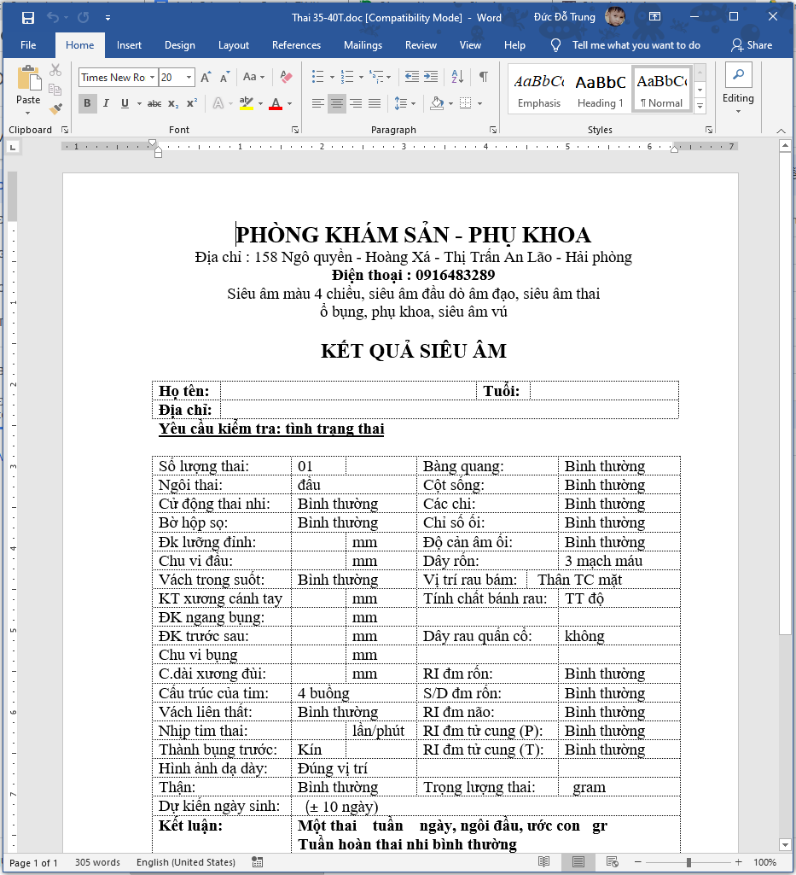

Figure 1: Ultrasound Clinic template

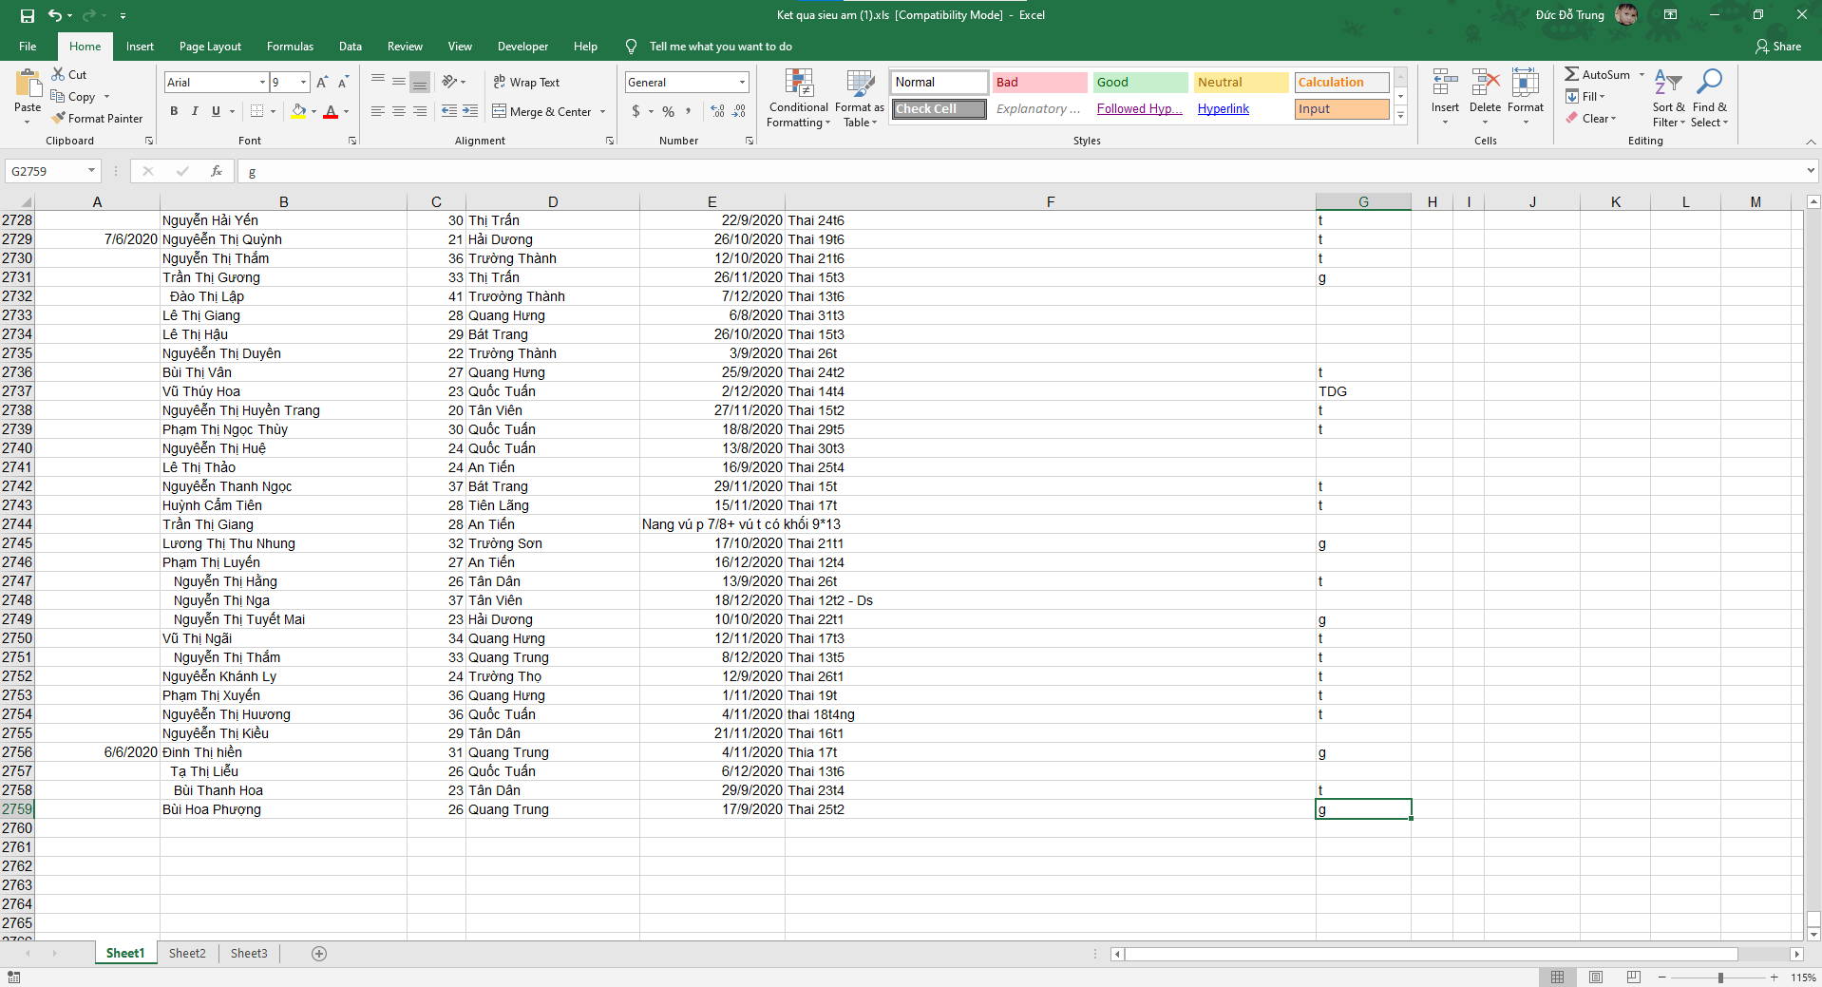

Figure 2: Ultrasound Clinic

***As-is:***

* **Step 1:** Patients in need of examination (can be scheduled by phone).
* **Step 2:** The nurse asks the patient what service ultrasound they want to use and then opens the “*template corresponding*” to the service on the computer.
* **Step 3:** The doctor examines the patient. During an ultrasound, the doctor will read the results and the nurse will fill in the results.
* **Step 4:** After the ultrasound is complete, the nurse prints the ultrasound results for the patient.
* **Step 5:** After the above step, the nurse must open the Excel file and re-enter the Word file information above to manage the medical records.
* **Step 6:** The doctor prescribes the drug to the patient.
* **Step 7:** The patient takes the medicine at the pharmacy and pays for it.
* **Step 8:** When the old patient comes to the examination, the employee must look up the patient's information in the Excel file.

***Pain-point:***

* Using cash for payment is the main method
* Difficult to find patients, the number of patients with the same names on the excel file is too many.
* Takes time in importing word files to excel files.
* Difficulty in filtering outdated data.
* Difficulty in managing word files, excel templates.
* Difficulty administering drugs according to various information (date of entry, quantity, expiry date, supplier, unit price).

***Pros & cons:***

|  |  |
| --- | --- |
| **Pros** | **Cons** |
| * Simple to use. | * File loss, data loss (crashing computer, virus, ...). * Ease of input data errors. * Medicine management in paper. * There is a high cost compared to many clinics. * Difficulty in data statistics.. |

### 

### 3.2 BigSoft

***Name*:** BigSoft

***Description*:** Eye clinic management system.

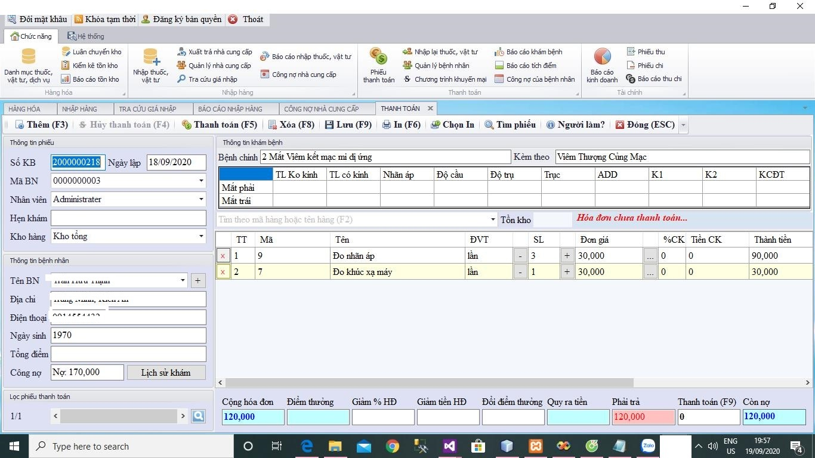

Figure 3: Existing system BigSoft

***As-is:***

* **Step 1:** The patient comes to the clinic.
* **Step 2:** Nurses enter client information in the information section of the software.
* **Step 3:** The doctor examines the eye, then the nurse enters the result information into the software.
* **Step 4:** The doctor concludes the main disease and then the nurse enters the information into the software.
* **Step 5:** The doctor prescribes the service or prescribes the medicine and then enters the information into the software.
* **Step 6:** Nurses use software to print bills.
* **Step 7:** Patients pay for drugs and services.
* **Step 8:** The nurse noted the patient paid on the software.

***Pain-point:***

* The software has no reports on the shelf life of the drug.
* There is no customer support channel.
* The system does not decentralized access.

***System actors:***Administrator

***Features:***

* Management of medical records.
* Financial management, revenue.
* Manage pharmacies, drug stores.
* Medical consumption management.
* Create reports, statistics.
* Subclinical management.
* Management re-examination.
* Suppliers management.

***Pros & cons:***

|  |  |
| --- | --- |
| **Pros** | **Cons** |
| * Simple software interface. * The software still works normally without the internet. * High Secure. * Simple user interface that is easy to use * Installed directly on an offline computer. Not affected by the internet. | * Only run Windows computer environments. * The software does not divide roles. * The manager cannot manage it remotely. * Do not immediately switch to another computer for use when the computer is currently using the problem (virus, win error, ...) |

### 

### 3.3 Nano clinic

***Name*:** Nano clinic

***Description*:** ABClinic management system.

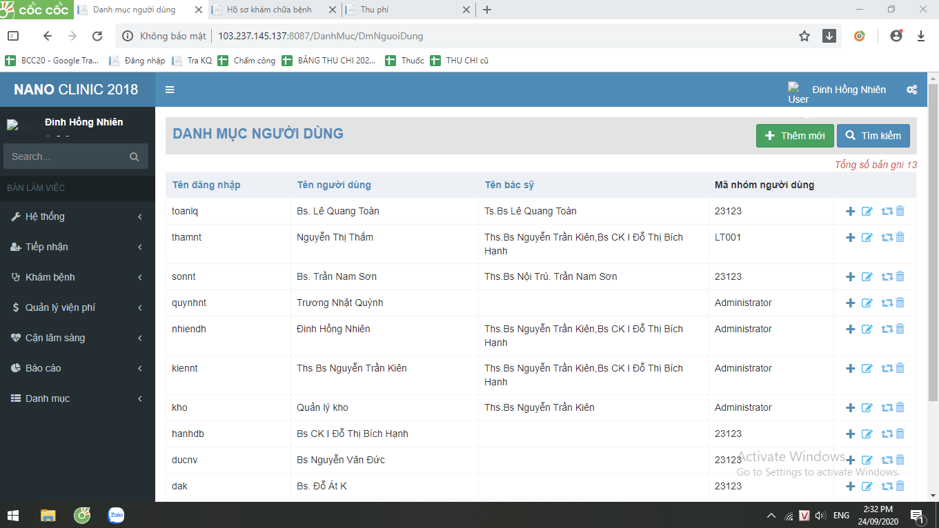

Figure 4: Existing system Nano clinic

***As-is:***

* **Step 1:** The patient makes an appointment with the doctor in advance about the examination schedule.
* **Step 2:** The patient comes to the clinic.
* **Step 3:** The receptionist nurse enters administrative information (name, age, address, ...) into the software.
* **Step 4:** The nurse asks the symptom and asks the patient what he wants to do, then generates the questionnaire in the system.
* **Step 5:** The nurse takes the patient to see the doctor.
* **Step 6:** The doctor does a preliminary check (heart, pulse, blood pressure), but the results are not saved to the system.
* **Step 7:** The doctor or nurse chooses which tests to perform on the "*medical tests prescription*" form on both system and paper .
* **Step 8:** The patient goes for an examination then brings the "*medical tests prescription report*" back to the doctor.
* **Step 9:** The nurse captures the "*medical tests prescription report*" and then saves them on Google Drive.
* **Step 10:** The doctor diagnoses and “*prescribes*” the drug.
* **Step 11:** The patient payment and nurses use the system to print bills.

***Pain-point:***

* Some features are not necessary and do not save user time compared to manual jobs available at work.
* Some features are slow to respond.
* The software does not have cost and debt management features.
* Test results when you want to save on the software, the implementation steps are still very complicated.
* It is not possible to compare many old patient results directly on the software.
* Cannot be used if the clinic has multiple branches.

***System actors:***Administrator

***Features:***

* Manage users on the system
* Manage categories.
* Receiving patients.
* Manage medical examination process.
* Financial management.
* Report management, systematic statistics.
* Management of drugs and supplies.
* Manage subclinical examination.

***Pros & cons:***

|  |  |
| --- | --- |
| **Pros** | **Cons** |
| * High Secure. * Help management wherever you are. * Unlimited device access number. | * The software still has many bugs. * The software cannot be used without a network. * Software has complex business. Difficult to use, making it difficult to manage and supervise clinic business activities. * There is a high cost compared to many clinics. * It does not respond to the detailed management requirements of the clinic. |

### 

## 4. Business Opportunity

Many private clinics require a management system tailored to the size and characteristics of their clinic. Graphic user interfaces are easy to use and full of management functions. However, the owner of the clinic can manage anytime, anywhere and makes it easy for patients to book appointments. Such a management system will help the clinic operate more smoothly, saving more time and money. It doesn't take employees too long to report and handle the archive. Receiving and processing patient records, optimal testing.

## 5. Software Product Vision

For private clinic owners who manage online clinic operations on the internet, laptops help to manage more accurately and transparently. Unlike the current management software, when the power is out or Windows is not installed, it will be difficult to handle medical requirements. Plus, when using a web-based application, you can easily manage it on your phone. Besides, when there are features suitable to the size and needs of the clinic, it will help to handle and manage the clinic more optimally over time.

## 6. Project Scope & Limitations

### 6.1 To be

* **Step 0:** Patients can make an appointment or come directly to the clinic (In the case of appointment will be given priority in order)
* **Step 1:** Patients who come to the clinic meet the nurse in the patient admission office.
* **Step 2:** The nurse asks the patient whether to come for the new examination or re-examination
  + Case 1: Patient comes for the new examination:
    - Nurses fill administrative information (name, age, address ...) into the patient reception window on the system.
  + Case 2: Patients come to re-examination or have been examined at the clinic:
    - Nurses find the patient's administrative information already available.
* **Step 3:** The nurse asks the patient's symptoms and wishes (what examination, which doctor?) And creates the “*medical examination forms”*of patients on the software.
* **Step 4**: The nurse printed the “*number card”* to the patient ( ordinal numbers, consulting room name, doctor) given to the patient.
* **Step 5:** Patient pays for medical services at cashier’s, the cashier prints the bill with the payment confirmation for the patient.
* **Step 6:** Patients who come to the waiting room see the consulting room name and ordinal number.
* **Step 7:** The doctor will do a physical examination (measure blood pressure, heart rate, temperature, ask medical history, ...) and record the results into *medical examination form* on the system.
* **Step 8:** Doctors diagnose the disease
  + Case 1: Appoint patients to perform subclinical services (ultrasound, blood, urine, endoscopy, X-ray ..) on the “*medical tests prescription”*and print it given to the patient.
  + Case 2: In case of not doing subclinical services, the patient will be prescribed the drug on the "*prescription*" form by the doctor.
* **Step 10:** Patient comes to pay for subclinical services at cashier’s ( the cashier prints the bill with the payment confirmation for the patient).
* **Step 11:** Sampling patient (In case of ultrasound or X-ray, endoscopy, .. patient will be taken to ultrasound room / scan and wait for ultrasound / scan).
* **Step 12:** Patients who receive results after completing a subclinical service such as a “*medical tests prescription report* “back to the previously designated physician.
* **Step 13:** Doctors diagnose the disease according to “*medical tests prescription report*” thereafter fill in “*medical examination form”* and the drug on the "*prescription*" form by the doctor (if any).
* **Step 14:** The patient brings "*prescription*" to the pharmacy and payment ( the cashier prints the bill with the payment confirmation for the patient) thereafter receives medicine.

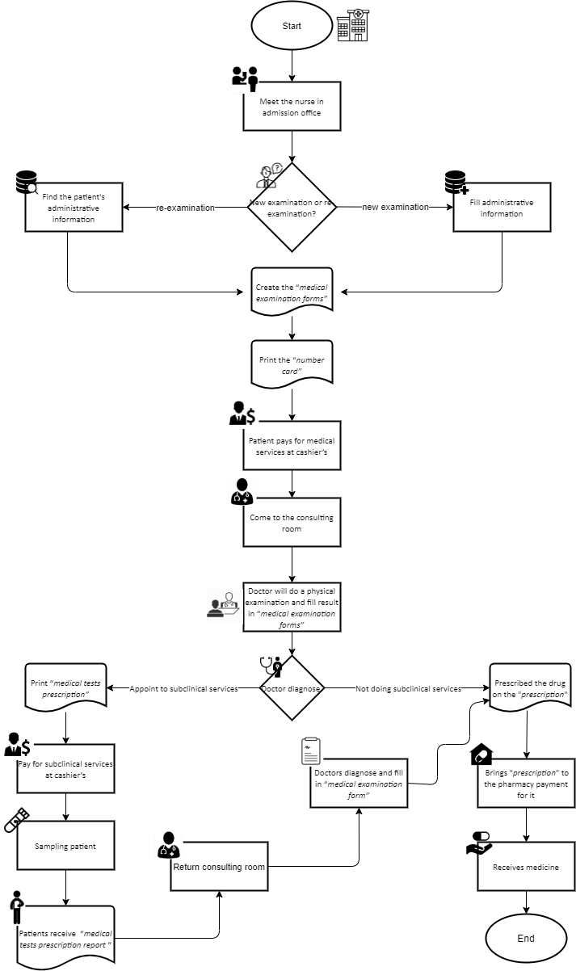

Figure 5: Flowchart tobe of CMA

### 6.2 Major Features

**6.2.1. Role staff**

* Make an appointment.
* Manage appointments.
* Receiving the patient (making the “*medical examination form”*) in the Admission Office.
* Print the ordinal number slip (“*ordinal number”*).
* See the number of examined or waiting patients in each waiting room.
* Manage the list of “*medical examination forms”.*
* View the medical history and physical exam of patients.
* Enter the clinical examination results in the “*medical examination form”.*
* Indication of subclinical services.
* Print list type of “*medical tests prescription”* form.
* Enter the results diagnosed in “*medical examination forms”*.
* ***“****Prescribing****”*** to patients.
* Save “*medical examination form”* into the system*.*
* End of examination
* Receive “*medical tests prescription”*.
* Manage the list of subclinical examinations.
* Enter subclinical results according to the available forms.
* Print “*medical tests prescription report”*.
* Get patient information.
* Collecting fees service, confirming collection.
* Collection of pharmaceutical and materials fees
* Create a receipt for cash.
* Create a payment for cash.
* Create liabilities form.
* Statistics receipt of revenue and expenditure.
* Reporting patient liabilities.
* Reporting liabilities with suppliers.
* Patient contact information management.
* Create customizable reports for management
* Administration of drug entry.
* Statistics pharmaceutical and materials.
* Drug cancellation.
* Statistics on drug destruction.
* Make a stock release note.
* Statistics of material warehouse.
* Make a note to re-import drugs and supplies.
* Statistics of drug and materials re-import slip.
* Managing the drug list.
* Suppliers contact information
* Statistics prescriptions.
* Management of drug release.
* Statistics on drug sales.
* Re-import the drug.
* Medicines re-enter statistical sheets.
* Print invoice for sale.

**6.2.2. Role manager**

* Account management
* Account decentralization
* View the history of the system
* Report management template
* Generate customizable “*medical tests prescription”*form.

### 6.3 Limitations & Exclusions

LI-1: The system is only for medium-sized private clinics.

LI-2: Not affiliated with insurance.